**Impact of Maternal Education on Child Malaria Rates.**

**HDSC Spring 24 Premium Project**

**Team: Model Monitor**

Malaria is a major threat to public health around the world, but also, in theory, one of the most straightforward to address. Our studies have shown that the prevalence of malaria in children of mothers with no education was higher than children of educated mothers. We saw that maternal education has a direct and indirect influence on the child malaria rates. Basic education such as teaching mothers the importance of using treated malaria nets and also the importance of seeking treatment when the child develops a fever will do great justice to reducing malaria rates in under five children.

**Aim and Objectives**

The goal of the project is to analyse and give insights into the influence of maternal education on child malaria rates, and build a model to get deeper insights into the data.

**Flow Process**

The steps taken to build this project is stated below:

* Data gathering
* Data preparation
* Data collection
* Data processing
* Data transformation
* Data visualization
* Model training
* Model evaluation

**Data Gathering**

The data was gotten form UNICEF data through the link below: <https://data.unicef.org/topic/child-health/malaria/>

**Data Preparation**

The following process was used to process the data:

* Data collection: The dataset had 17 sheets. We had to choose the most important sheets from the dataset given. Out of the 17 sheets, we used only three.
* Data transformation: The data lead us to knowing that maternal education really does affect child malaria rates.
* Data visualization: findings were made here using histogram for maximum interpretation.

**Exploratory Data Analysis**

Further steps were taken to give a clear pictorial description of the data.

**MLRCARE** - Percentage of children with fever under the age of five for whom treatment was sought. This is our first sheet visualization and modeling.

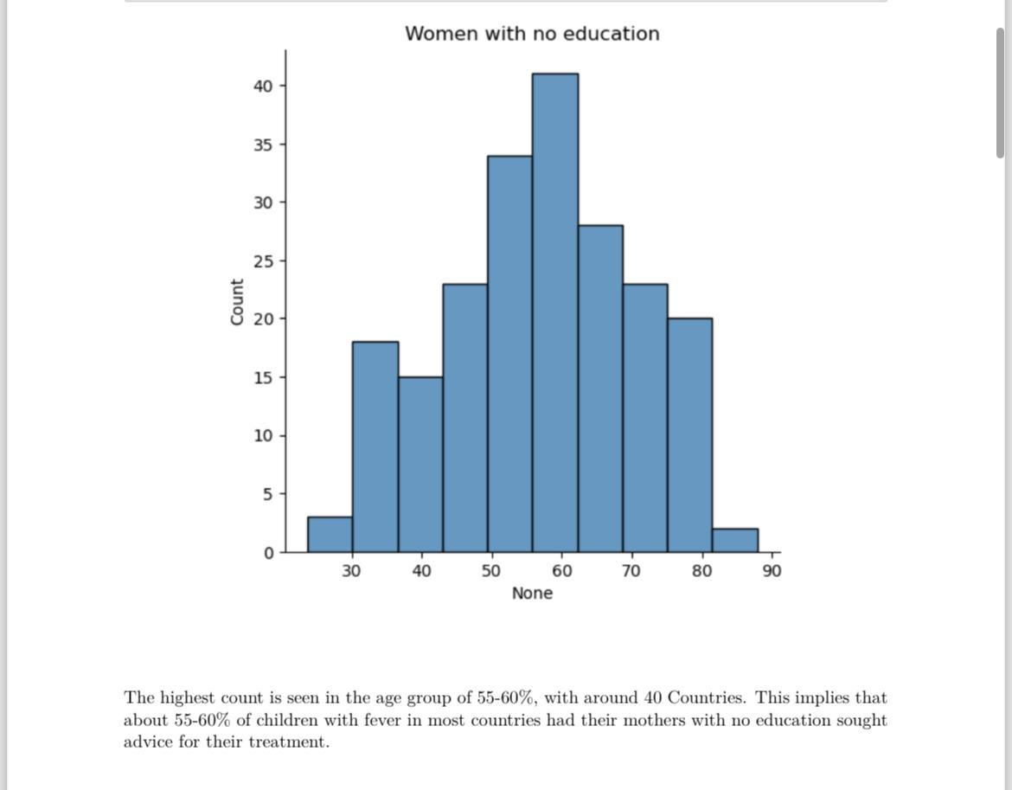

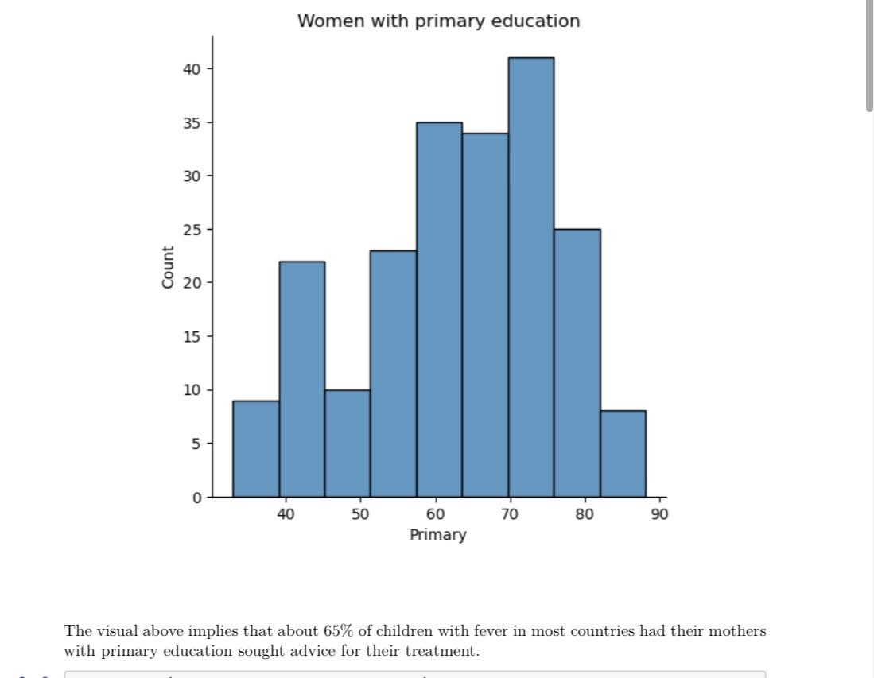

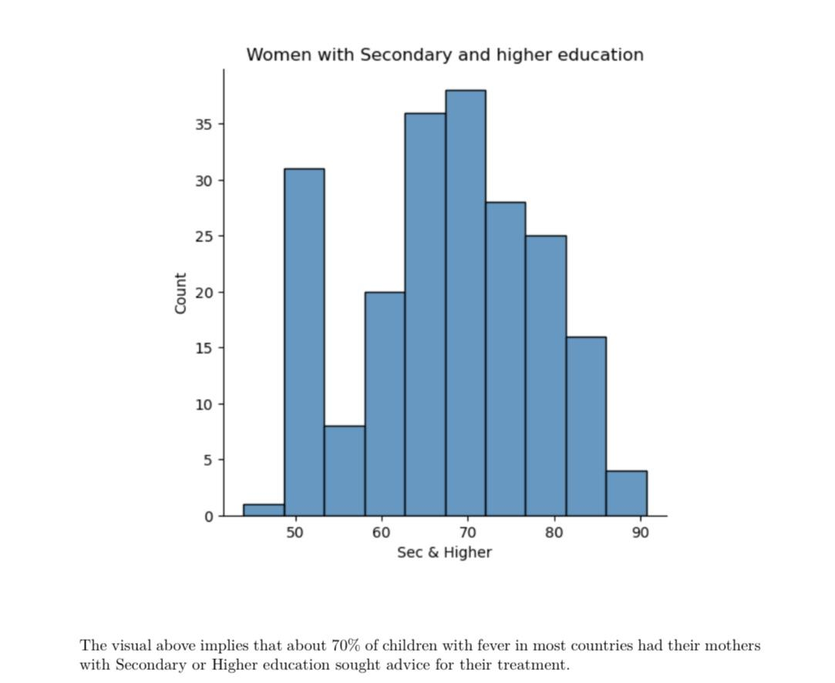

**MLRDIAG -** Malaria Diagnostic Usage - Percentage of febrile children (under age 5) who had malaria diagnosis.

The visualization below analyses our second sheet.

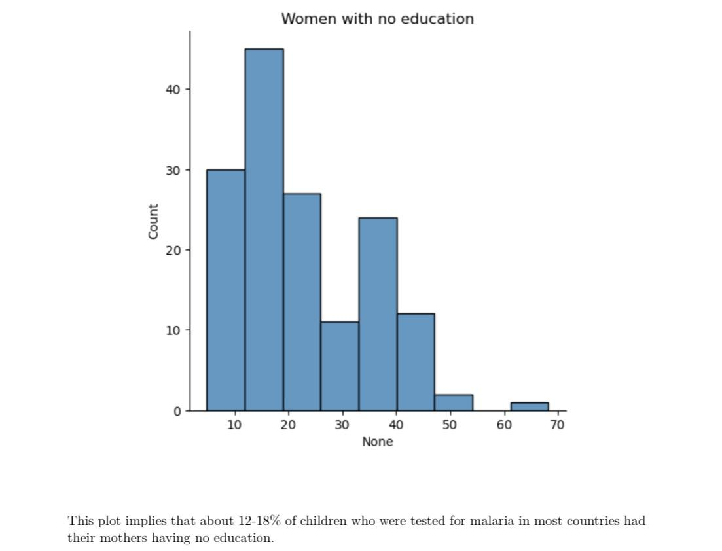

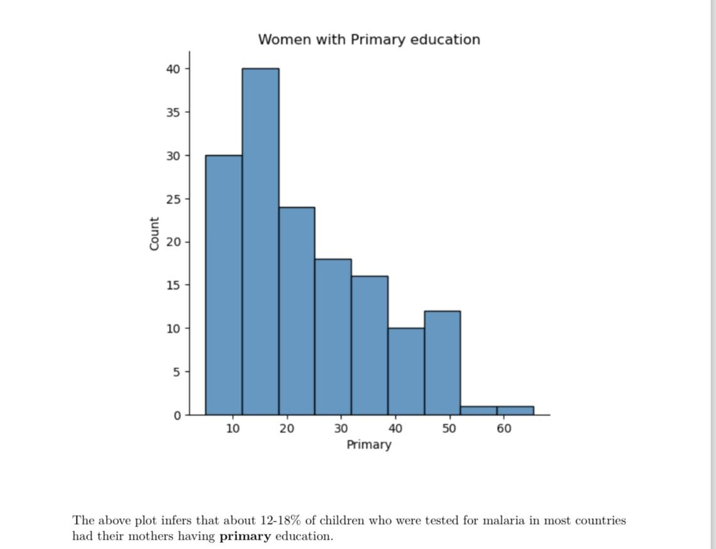

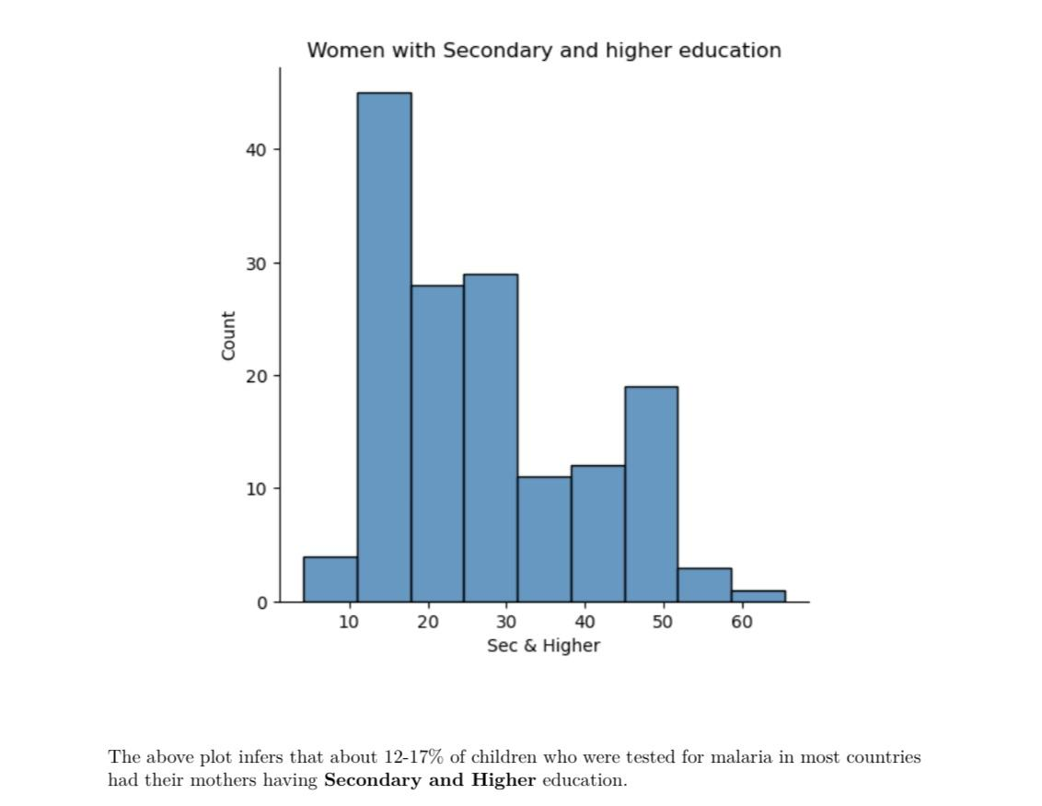

**MLRACT -** First-line treatment (ACT) for children under age 5 with fever- Percentage of febrile children (under age 5) receiving ACT (first-line anti- malarial drug), among those receiving any antimalarial drugs. This is our third sheet. The visualization below analyses our third sheet.

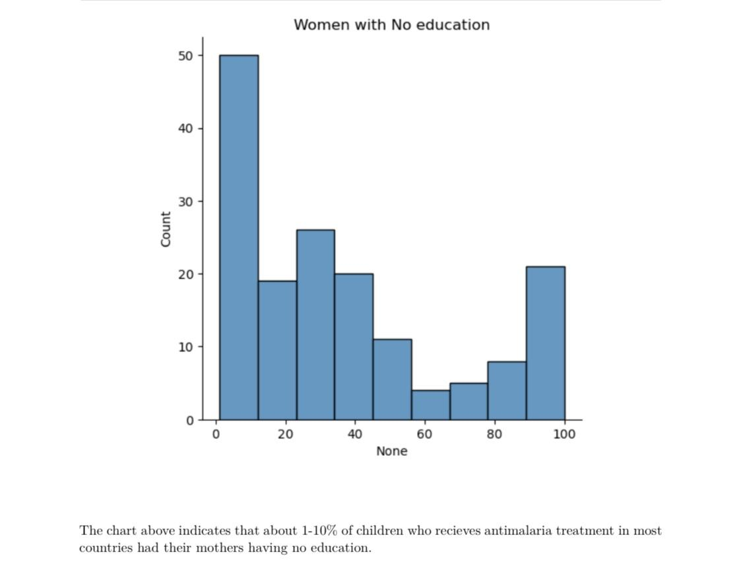

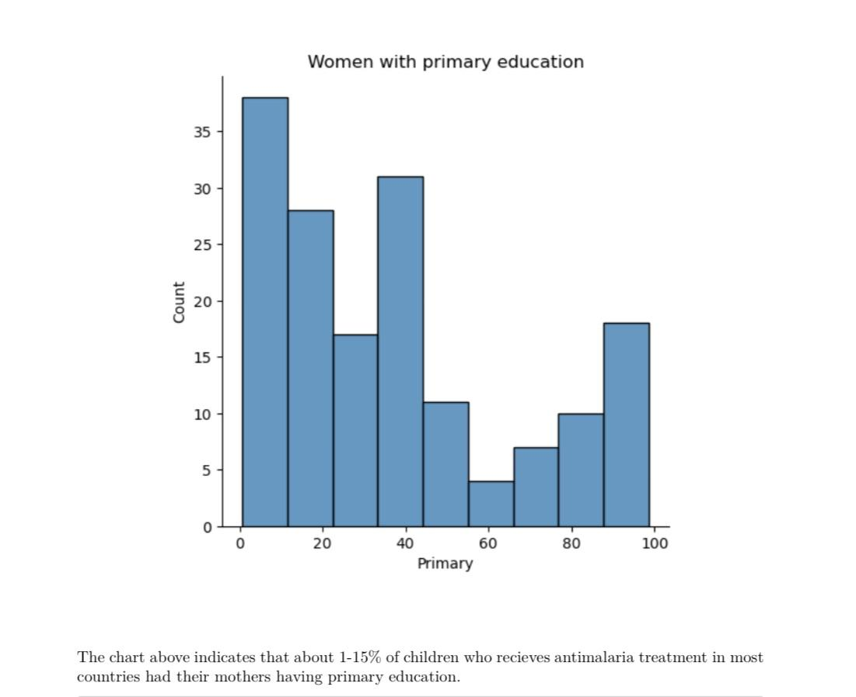

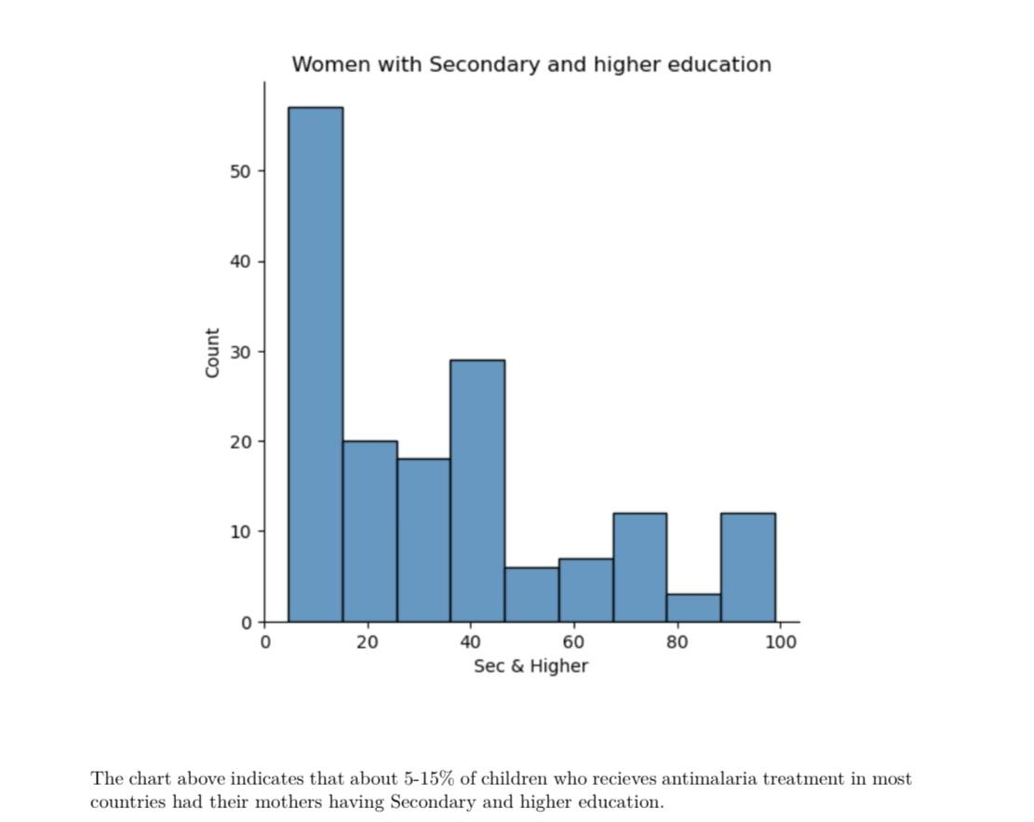

**Model Training**

In order to ensure the creation and validation of our model, the dataset was divided into two parts: The training set and the testing set.

**Model Evaluation**

In the evaluation of the model, we used linear regression and we also found the coefficient of the data.

**Results**

The findings indicated that the higher a mother’s education, the lesser chance of the child being infected with malaria. This analysis will help put more focus in the area of maternal education.

**Conclusion and Recommendation**

The most important aim was to analyze our data. The aim of machine learning is to create algorithms that enable a system to automatically collect data and use the data to learn more. To avoid inaccurate results and to get deeper insights into our data, it is important to always gather accurate, current and relevant data.